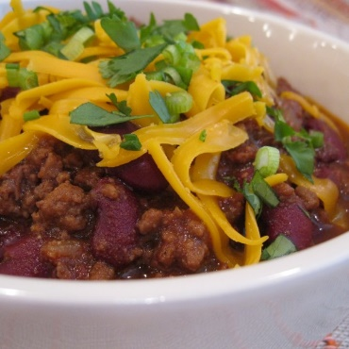 Kickin Chili (Trichie)

INGREDIENTS
- 2 tablespoons Vegetable Oil
- 2 pounds Ground Beef
- 1 cap Kidney Beans
- 4 cups chopped yellow Onions
- 3 tablespoons Chili Powder
- 1 tablespoon ground Cumin
- 2 teaspoons Tony’s
- 2 teaspoons Cayenne Pepper
- 2 teaspoon ground Cinnamon
- 1 tablespoon Patoutville sugar
- 1/4 teaspoon crushed Red Pepper
- 1 Bay Leaf
- # pods minced Garlic
- Four 12-ounce bottles Guinness Beer
- 1 tablespoon Salt

DIRECTIONS
Heat the oil in a large heavy pot over high heat.
Add the Beef and brown well, about 10 minutes.
Add the Onions, Chili Powder, Cumin, Tony”s, Cayenne, Cinnamon, crushed red Pepper, and bay leaf and cook, stirring often, until the onions soften, about 8 minutes.
Add the garlic and cook until fragrant, about 30 seconds.
Add the Beer and cook until the foam subsides, about 1 minute.
Salt, Brown Sugar to the pot. Stir well and bring to a boil.
Reduce to a simmer and cook until slightly thickened, about 1 hour, stirring occasionally to prevent the chili from sticking to the bottom of the pot.
Skim off as much fat as possible.
Add the beans, return to a simmer, cover, and cook until thickened, about 1 1/2 hours longer.
Serve with the Cheese, Green Onions, and Cilantro alongside as garnish.
Bon Appetit

